**Design Concept:**

The main purpose of this website is to allow more people to participate in the testing and learning of knowledge. The website enhances the user's enthusiasm by ranking, and then rewards the user (in preparation). Users can discover and learn a lot of unpopular knowledge or common sense when they play the games on this website.

**Ways of profit**: The website is profitable through advertising and sponsorship (profit and non-profit organizations).

**Culture**: A diverse cultural background will appear in the question, which can detect the user's knowledge reserve.

**Experience**: Users can answer questions here, also can discuss and submit questions with others (user communicating zone will be added in the future).

**The mockup design of this website.**

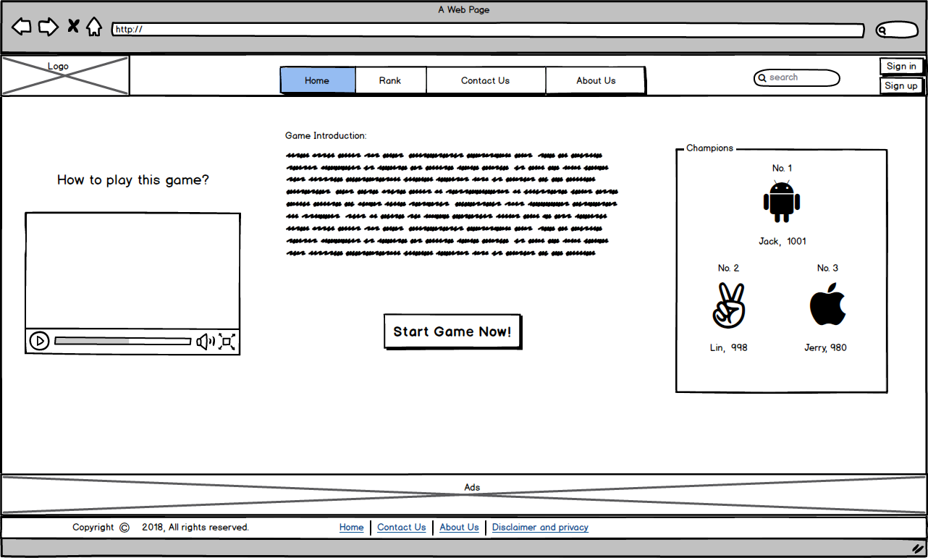

Home page

This is also a default page when someone who open this website.

In home page, there is a navigation bar in the top. The navigation bar includes website logo, navigation of this site, search engine and Log in/ register buttons. In the middle of this page, there were three parts, a video introduction, a text introduction and the rank champions No.1 to 3. At the bottom show advertisement and footer bar.

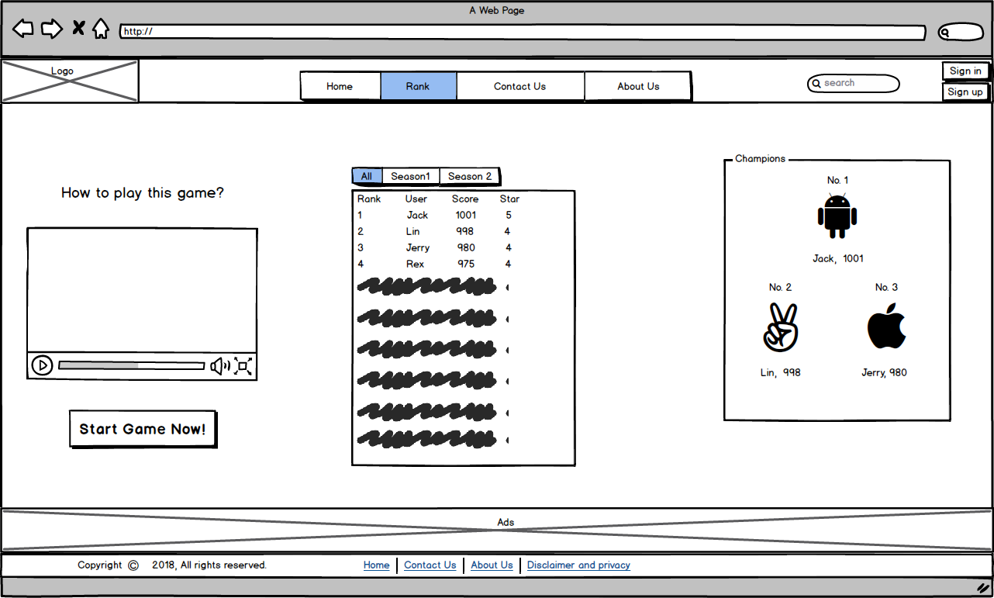

Rank page

In the middle, show the rank list. This list includes the number of rank, user’s name, user’s score, user’s star and different game seasons.

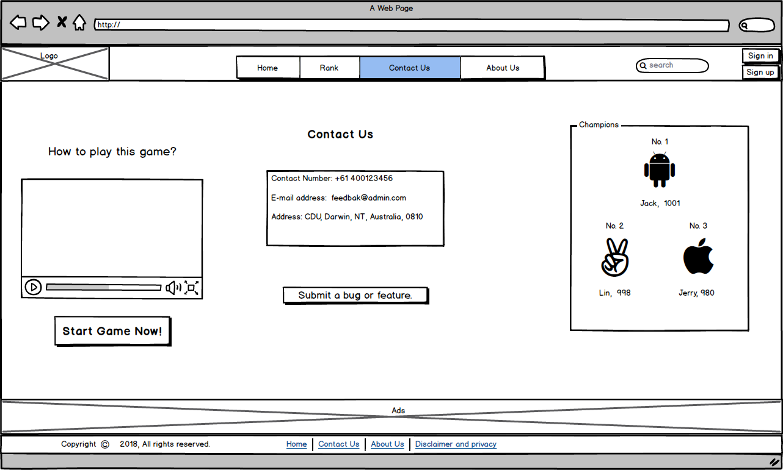

Contact Us page

Contact page have two features. Firstly, show the contact details of our website. Then, user can submit bug and feedback to us.

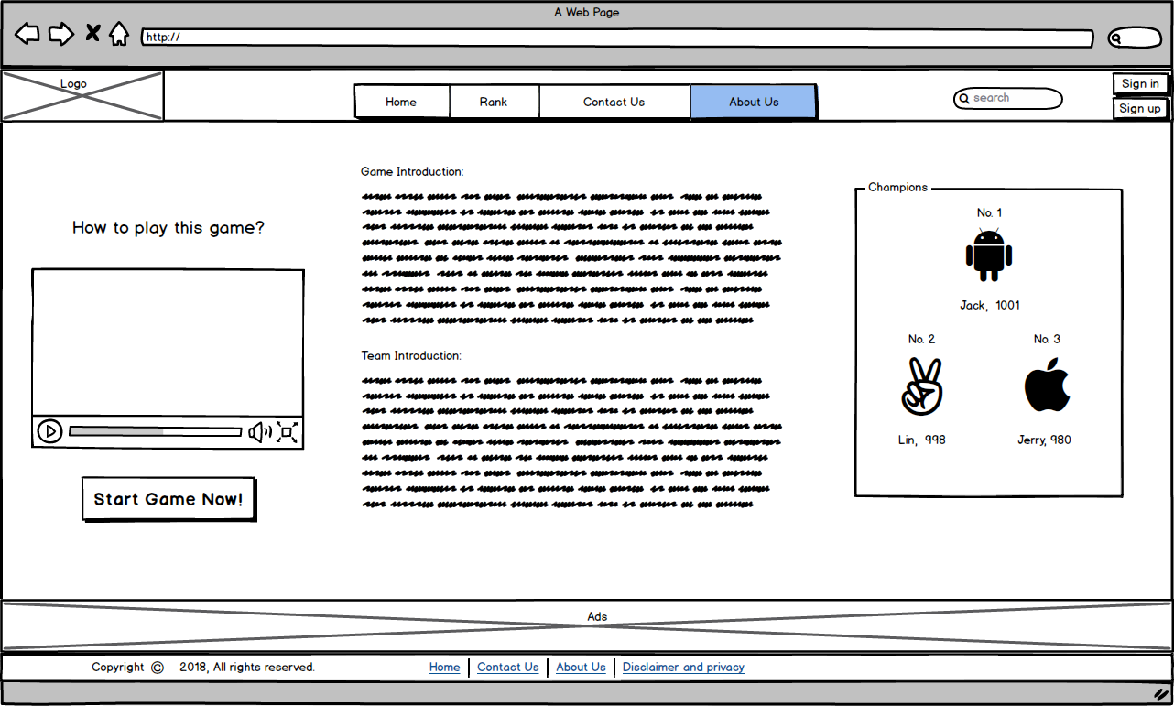

About Us page

In this page will show the details of our game and team members.

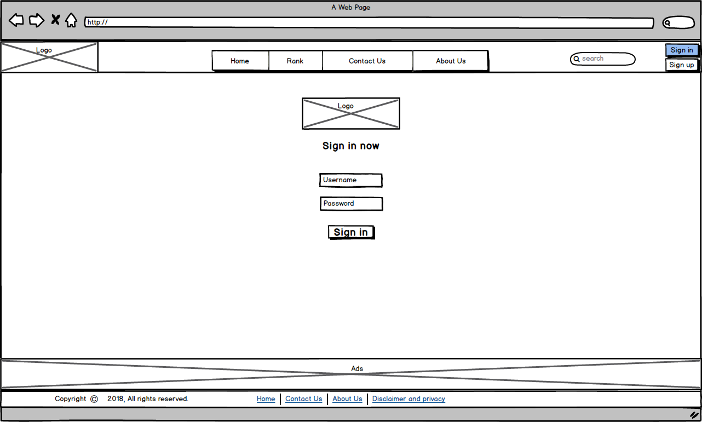

Login page

Simple login page. In the future user can user their social media account to log in this site.

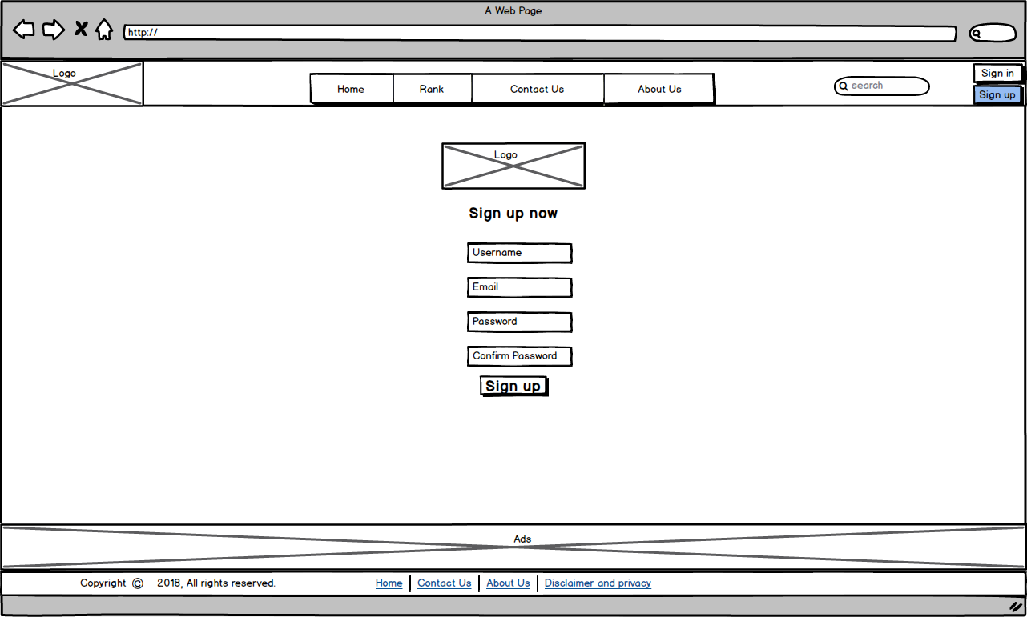

Register page

Basic and simple register page. User can easily get their account.

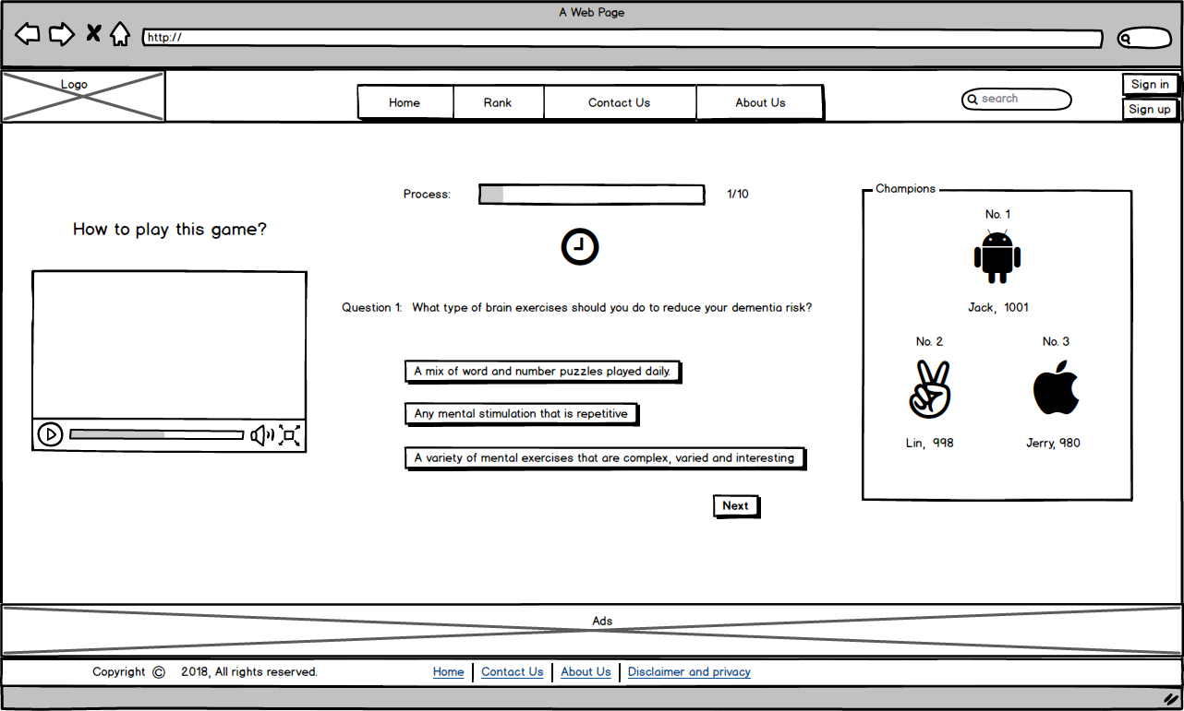

Game page

Game page gives a process bar, which can show the current process of a game. Also show the time below process bar. After, there is the question and question’s options. When user type one answer and push ‘Next’ button or when this question overtime, the process will go to next question until question number 10.

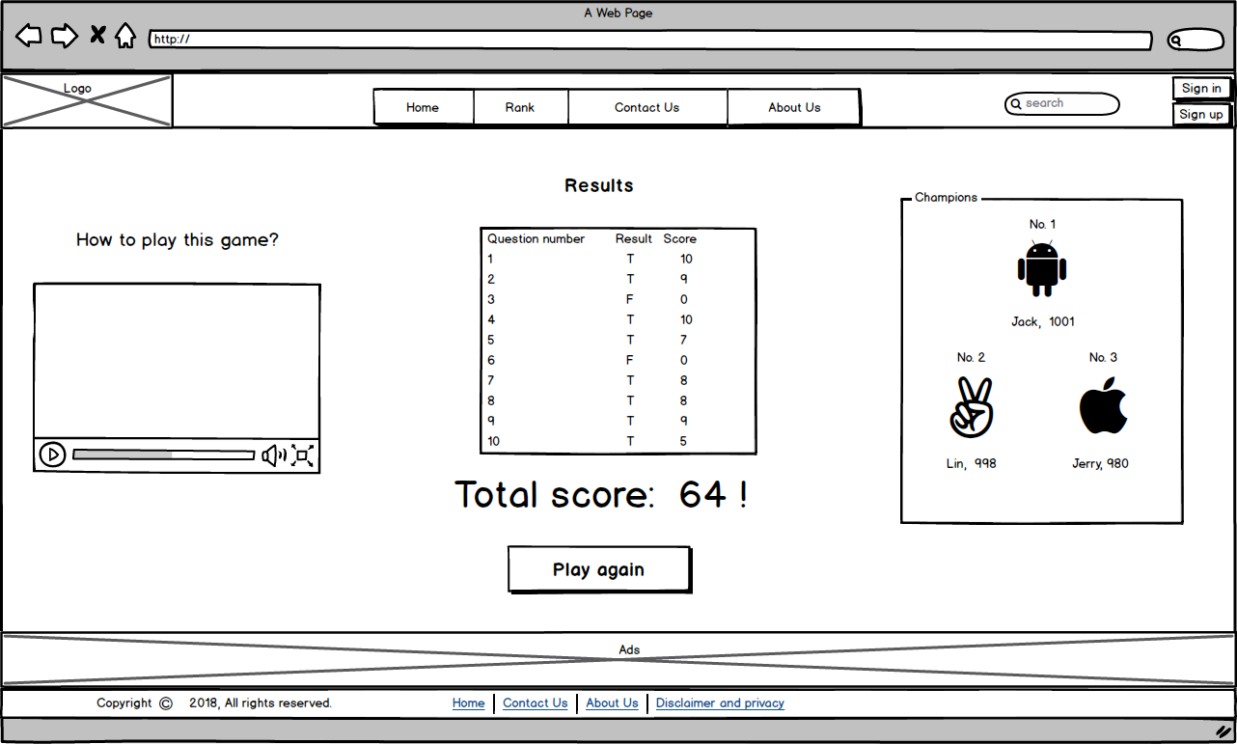

Results page

This page will show the game score, questions have different score which based on the finish time of this question. Then show the total score of this game. In the future, we will add ‘share’ function to allow user sharing the score to social media.